FULL STACK WEB DEVELOPER

Get Started with Web Development

Agile scrum Foundation

DAY - 1

Agile Approaches:

Scrum

XP

Crystal

Kanban

Scrum

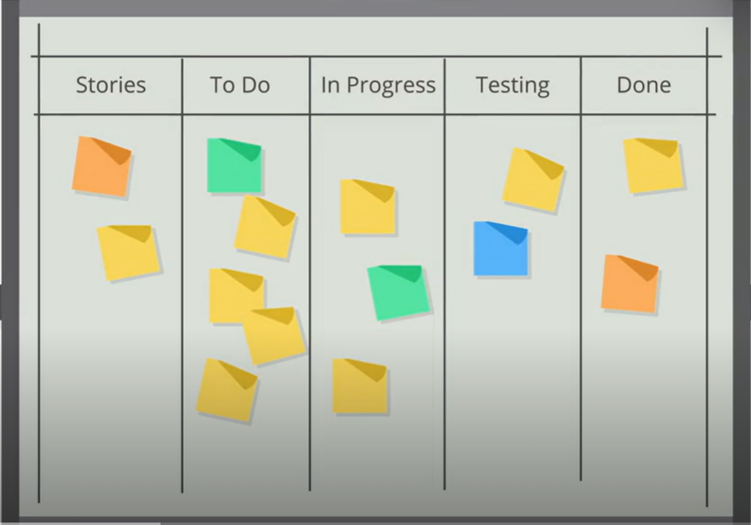

Project management Approaches:

Waterfall approach

Agile approach

Agile Approach :

Emerged in the late 1990’s to address the need for an alternative to a heavy weight documentation driven process.

Agile Manifesto :

Written in February , 2001, in park city , Utah , by seventeen leading software developers.

Agile Manifesto :

Statement of Value:

Individuals and Interactions over process and tools

Working software over comprehensive documentation

Customer collaboration over contract negotiation

Respond to change over following a plan

More than the values on the right sides the values on the left side are given importance more.

On the right hand side those are the things which are most common for traditional waterfall approach .

On the left hand are agile in nature.

Individuals and Interactions deliver better results when the emphasis is not on the processes and the tools.

Emphasis on working software can deliver the real progress or value.

Organizations need to be accommodating rather than following detailed definition list in contracts.

Customer suggestions are to be incorporated to deliver the value the customer wants.

Waterfall Model :

System Requirements

Software requirements

Analysis

Program Design

Coding

Testing

Operations

Agile – Key features:

Focus on people – The focus is on professionals and how to optimally use their professionalism.

Customer Involvement – Customer determines the scope of the project, prioritizes the work, and the reviews of the product.

Multidisciplinary Teams – The team includes different specialties delivering the working software to the customer.

Trust – It is the basic characteristics each team member should have.

Incremental – Working software is delivered to the customer in short increments.

Time Boxes – Predetermined amount of time never to be exceeded by the team.

Address the quality of the software being delivered to the customer.

Metrics for Agile project – Escaped Defects

Agile team determines how things will be measured during the course of the project.

Defects that were not found by, or ones that escaped from, the quality assurance team, but found by the customer.

Agile methods:

Scrum

Lean

Moscow

Crystal

Kanban

XP

All agile methods use The agile manifesto as their fundamental guidance.

Agile Methods – scrum:

A framework that uses tools and practices developed for other agile methods.

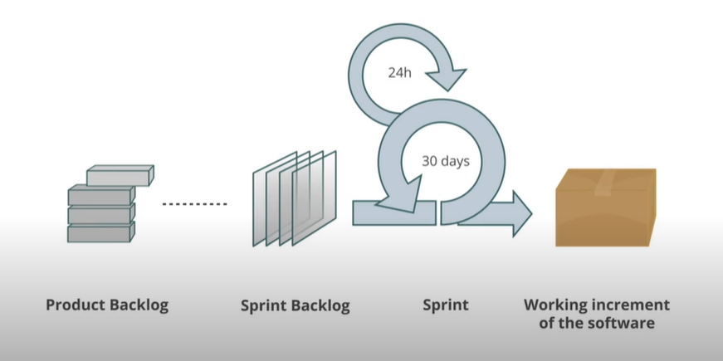

XP:

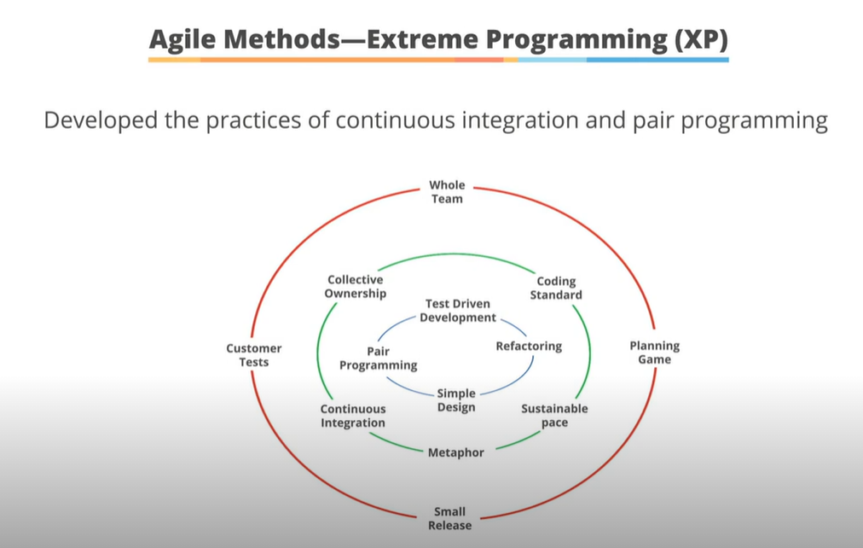

Crystal :

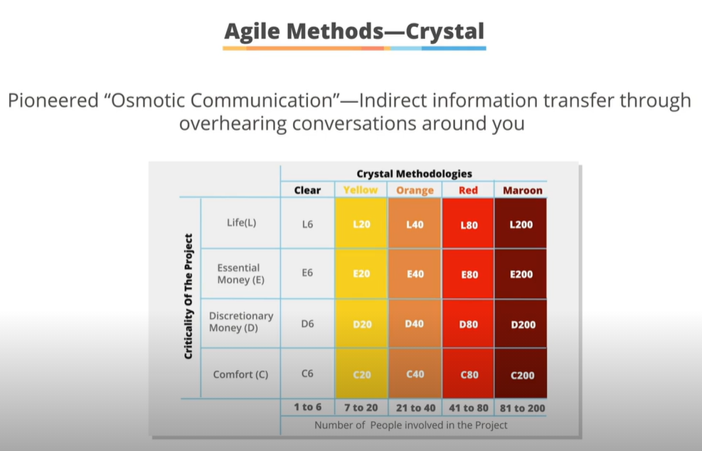

Kanban:

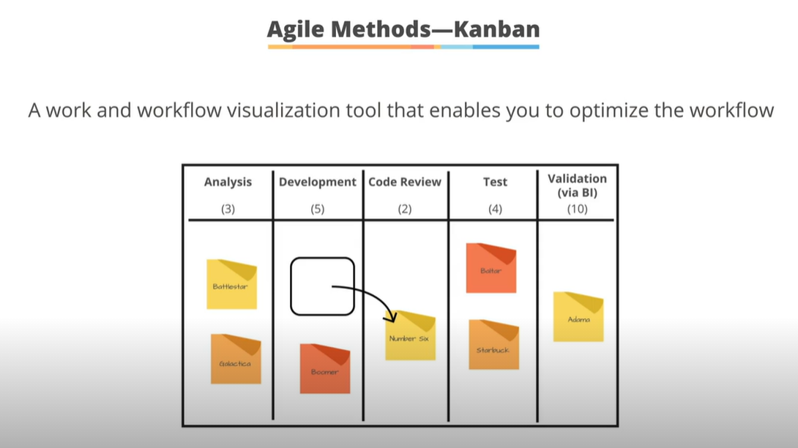

Moscow:

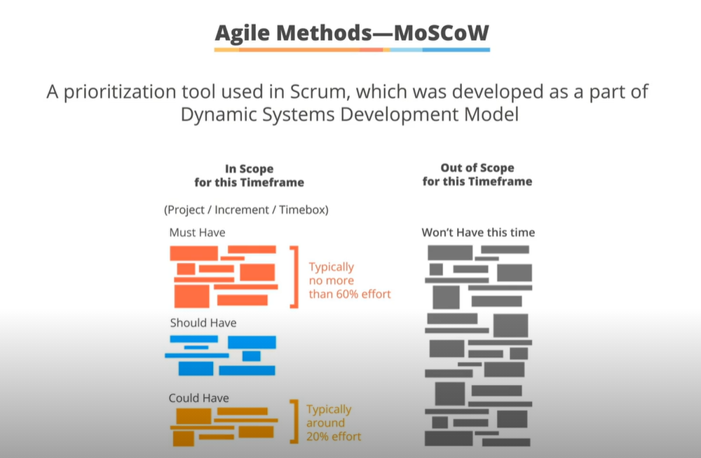

Scrum :

A lightweight framework designed to manage complex product development.

Promotes developing products of the highest possible value in an iterative and incremental way.

A framework within which various processes, techniques and practices are employed.

Iterations are called sprints.

Each sprint results in a potentially shippable software

Scrum Overview:

